Memorandum
Date: 11/3/2024
From: Ralph Lampman, Yakama Nation Fisheries
Laurie Porter, Columbia River-Inter-Tribal Fish Commission
Aaron Jackson, Confederated Tribes of the Umatilla Indian Reservation
Tod Sween and Raymond Ellenwood, Nez Perce Tribe
Lyman Jim, Confederated Tribes of Warm Springs
To: Trevor Conder, NOAA Fisheries
Subject: Regarding “NOAA Fisheries recommendation that lamprey openings in FCRPS fish ladders be limited to 1.5 inches or less”

As the CRITFC member tribes and others invent new structures specifically designed for passing Pacific Lamprey, there is a need to ensure that as many lamprey can and will use these infrastructures (on first attempts). Floating Adult Pacific Lamprey [Operation Nocturnal] (FALCON) is one example of this. As the region investigates these future projects and advancements, we would like to see assessments on larger openings to ensure all sizes of adult lamprey can pass through with no issues.
The NOAA Fisheries memo dated May 13, 2015, and titled “NOAA Fisheries recommendation that lamprey openings in FCRPS fish ladders be limited to 1.5 inches or less” 1) does not prove that lowering height from 2 inch to 1.5 inch has no negative impact on lamprey and 2) does not prove that 1.75" (or potentially 2") height has any measurable impact on salmonids. It does demonstrate that there is some level of salmonid interaction when it is at 2.5 inch. The memo states that “The resolution of the underwater cameras in these locations preclude being able to determine if the fish actually made contact with the opening hence the use of the metric ‘interaction’ as a conservative surrogate for potential injury.” Despite some interaction being observed (0.2 - 4.7%), the memo concludes that “migrating stocks of adult Chinook and sockeye salmon and steelhead trout were not remarkably delayed by the presence of lamprey orifices” (delay averaged 1.5-6.7 seconds).
The only study effects the memo discusses on salmonids is with a 2.5-inch height case study. No actual studies have been done with a 2 inch or 1.75 inch height. There is an anecdotal observation that discusses how a 1.5-inch opening excluded all sockeye from entering, whereas 30-50 may have potentially entered a 2-inch opening due to rocks stuck in the picket lead guides. However, there is no clear evidence that this measurement by the Corps staff was done precisely or accurately (i.e. not estimated) and was measured at the exact spot that sockeye actually entered; it is certainly possible that there may have been a location that had slightly larger opening [e.g., 2.25 inch or even 2.5 inch opening] that was not easily observed or measured or the gap was simply measured quickly (without accounting for the actual gap). Placing too much weight on this one isolated incident to “define” the acceptable opening for Pacific Lamprey in perpetuity seems problematic for both species and at the very least it deserves another examination.
Literature that discusses adult salmon collection and trapping (versus those that target juvenile salmon) indicate that a mesh size of 2-4 inches is the standard and typically used (Hahn et al. 2007; Raby et al. 2015), and other studies that specifically target sockeye salmon using beach seining (Donaldson et al. 2011, 2012, 2013; Nguyen et al. 2014) indicate that they use 2 inch mesh size for collection.
For lamprey, the text below is the evidence that the memo provides to conclude that "The available information indicates lamprey have little difficulty and can readily pass a 1.5 inch vertical opening.":
“These researchers also note that a large proportion 20-30% of lamprey pass through 1 inch picket lead bar spacing at Bonneville Dam, and raising picket leads 1 inch at Bonneville approximately doubled passage from 23% to 46.7% in 2010 (Thompson et al 2015). This indicates lamprey do not have any apparent difficulty navigating through vertical openings of 1.5 inches or less.”
There is no data that show what percent of lamprey “can” versus “cannot” pass a 1-inch picket lead bar spacing in the memo; it only shows the increase in passage (from 0.75 inch to 1 inch). In the same paragraph, the memo describes the percentage of lamprey passing a 1.5-inch opening compared to other passage routes available; however, again, it does not provide any direct evidence for how many lamprey are able to pass versus turn around at these openings.
Figure 1A shows a histogram of adult Pacific Lamprey length during their collection from Lower Columbia River hydroelectric dams (data from CRITFC member tribes). Figure 1B shows the morphometric relationship between total length and maximum body width (by the gill area) after they have overwintered (some shrinkage in body sizes occur due to their cessation of feeding). As you can see, even after they have shrunk ~20% or so overall, including in girth, the majority of the lamprey have a body width that is mostly between 1.5-2.0 inches.
Moser et al. (2008) show that 14% (7 out of 50) were stranded on 1-inch opening in her experiment and these were found to be larger (primarily heavier) lamprey (see Figure 2 below); examining this graph further, a portion of lamprey (33%) that were between 530-620 g did not pass the 1-inch opening, and 100% of lamprey that were heavier than 620 g did not pass the same opening in this specific experiment.
Although 100% did pass a vertical screen that was 1 inch in height in this same study using another group of adult lamprey (Moser et al. 2008), the experiment was done in a way to pressure the lamprey to go through the screen (elucidating a freight response and there was no other escape route other than going through the small opening). In addition, the size of the study animals for the 1-inch height test may have had some influence; 658 g was the largest size lamprey and it is not clear how many individuals were > 530 g. In a normal setting where adult lamprey are migrating upstream, it is probable that some lamprey will initially turn around due to the tight opening (as they are not forced to escape as was the case in this particular experiment). For this reason, the ~86% passage (~14% failure) is likely more accurate as an estimate for what the initial passage rates with a 1-inch opening may be and it could very well be even lower if it was completely up to the lamprey’s discretion for passage rather than being dewatered/stranded and forced to move through to find to water down below as was done for this test. In fact, based on the histogram of Lower Columbia River Pacific Lamprey weight distribution (Figure 3), we can make an estimation based on Moser et al. 2008 that at least conservatively ~22.5% of the Pacific Lamprey may be turning around with a 1-inch opening. Although Pacific Lamprey are known to pass through openings that are slightly smaller than their maximum body width, a study examining their passage rates (and turnaround rates) using a 1.5-inch opening will be essential to understand the impact of this particular opening dimension on adult Pacific Lamprey.
In conclusion, given that 1) 2-inch mesh size is the “standard size” used for sockeye salmon trapping and collection (the smallest salmon that are most likely to interact with the lamprey orifices), 2) no clear evidence is available to show deleterious impacts from 2-inch or 1.75-inch opening (other than the one incident which does not show indisputable evidence that 2 inch was the most accurate opening size), and 3) morphology analysis indicates that lamprey maximum body width is typically > 1.5-inch (1.5 – 2.0 inch), we recommend that an interim criterion of 1.75-inch opening should be used for the time being till new studies indicate that some other alternative criterion is more appropriate.
Furthermore, we suggest that a new study to examine Pacific Lamprey passage rates with the 1.5-inch opening, including turn around rates, will be important, and until such a study is conducted, we should refrain from making the assumption that the 1.5 inch-opening has no negative impact on lamprey passage.
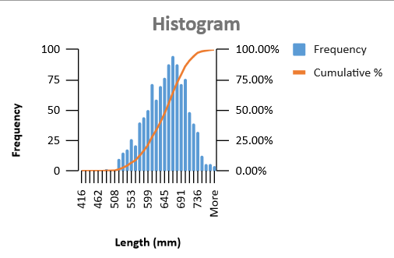
Figure 1A. Histogram of adult Pacific Lamprey length (initial migration period) from lower Columbia River hydroelectric dams.

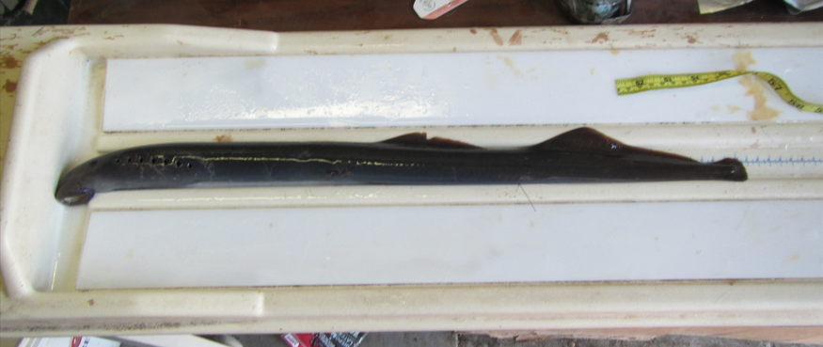
610 cm
(24.0 inch)
7.5 cm
(2.95 inch)
4.3 cm
(1.69 inch)
Figure 1b. A relationship between overwintered (spring) adult Pacific Lamprey length and maximum body width (by gill area) (above) based on photos taken during radio telemetry tagging events on April 18 and 19, 2015 (example shown below). When adults initially migrate, their length typically range between 500 – 850 mm (hence the range shown in the above figure with a trend line). Results from 40 samples are shown (more samples could be added and calculated if helpful, but the overall trend is clear that the majority of lamprey maximum body width is higher than 1.5 inch, even for these smaller overwintered adults).
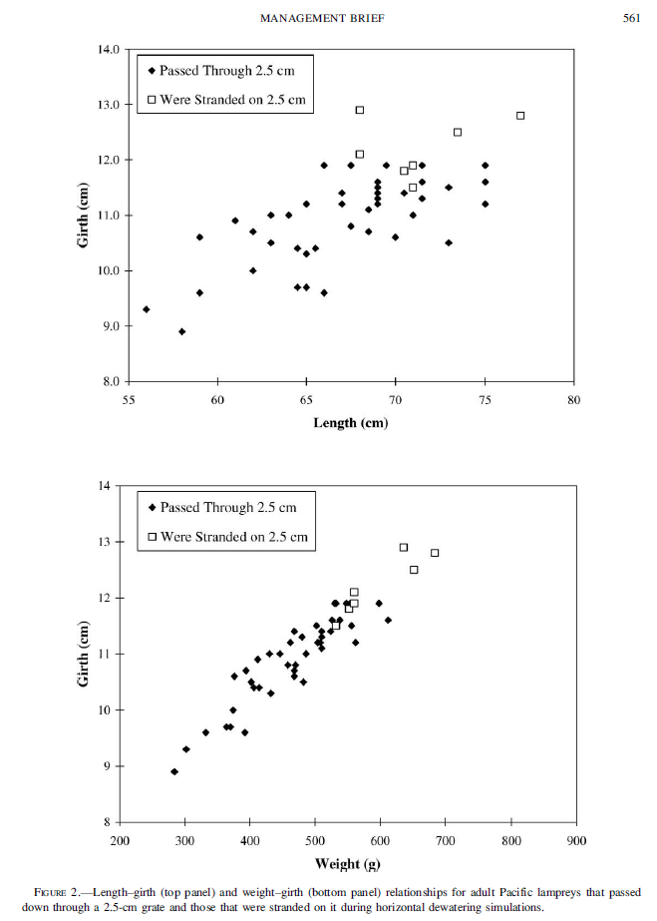
Figure 2. Directly inserted from Moser et al. 2008.
Figure 3. Histogram of a typical Pacific Lamprey run weight during their initial migration phase (Yakama Nation Fisheries data) as well as the expected stranded percentage based on weight (estimated using Moser et al. 2008). Based on simple calculations, those that are larger than 620 g is estimated to be 9.6%, and 33% of those that are between 530 g and 620 g is estimated to be 12.9%, totaling 22.5% (the estimated % that will not be able to pass a 1-inch opening).

References:
Donaldson MR, Hinch SG, Patterson DA, Hills J, Thomas JO, Cooke SJ, Raby GD, Thompson LA, Robichaud D, English KK, et al. 2011. The consequences of angling, beach seining, and confinement on the physiology, post-release behaviour and survival of adult sockeye salmon during upriver migration. Fish Res 108:133–41.
Donaldson MR, Hinch SG, Raby GD, Patterson DA, Farrell AP, Cooke SJ. 2012. Population-specific consequences of fisheries-related stressors on adult sockeye salmon. Physiol Biochem Zool 85:729–39.
Donaldson MR, Raby GD, Nguyen VN, Hinch SG, Patterson DA, Farrell AP, Rudd M, Thompson LA, O’Connor CM, Colotelo AH, et al. 2013. Evaluation of a simple technique for recovering Pacific salmon from capture stress: integrating comparative physiology, biotelemetry, and social science to solve a conservation problem. Can J Fish Aquat Sci 70:90–100.
Hahn, P.K, Bailey, R.E., Ritchie, A. 2007. Beach seining. D.H. Johnson (Ed.), Salmonid Field Protocols Handbook: Techniques for Assessing Status and Trends in Salmon and Trout Populations, American Fisheries Society, Bethesda, MA, pp. 267-323.
D.H. Johnson (Ed.), Salmonid Field Protocols Handbook: Techniques for Assessing Status and Trends in Salmon and Trout Populations, American Fisheries Society, Bethesda, MA (2007), pp. 267-323, 10.47886/9781888569926.fmatter
D.H. Johnson (Ed.), Salmonid Field Protocols Handbook: Techniques for Assessing Status and Trends in Salmon and Trout Populations, American Fisheries Society, Bethesda, MA (2007), pp. 267-323, 10.47886/9781888569926.fmatter

M. L., Moser, H. T. Pennington, and J. M. Roos. 2008. Grating size needed to protect adult Pacific Lampreys in the Columbia River basin. North American Journal of Fisheries Management 28: 557–562.
Nguyen VM, Martins EG, Robichaud D, Raby GD, Donaldson MR, Lotto AG, Willmore WG, Patterson DA, Farrell AP, Hinch SG, et al. 2014. Disentangling the roles of air exposure, gillnet injury, and facilitated recovery on the postcapture and release mortality and behavior of adult migratory sockeye salmon (Oncorhynchus nerka) in freshwater. Physiol Biochem Zool 87:125–35.
Raby, G.D., Donaldson, M.R., Hinch, S.G., Clark, T.D., Eliason, E.J., Jeffries, K.M., Cook, K.V., Teffer, A., Bass, A.L., Miller, K., Patterson, D.A., Farrell, A.P., Cooke, S.J., 2015. Fishing for effective conservation: context and biotic variation are keys to understanding the survival of Pacific salmon after catch-and-release. Integr. Comp. Biol. 55, 554–576.

